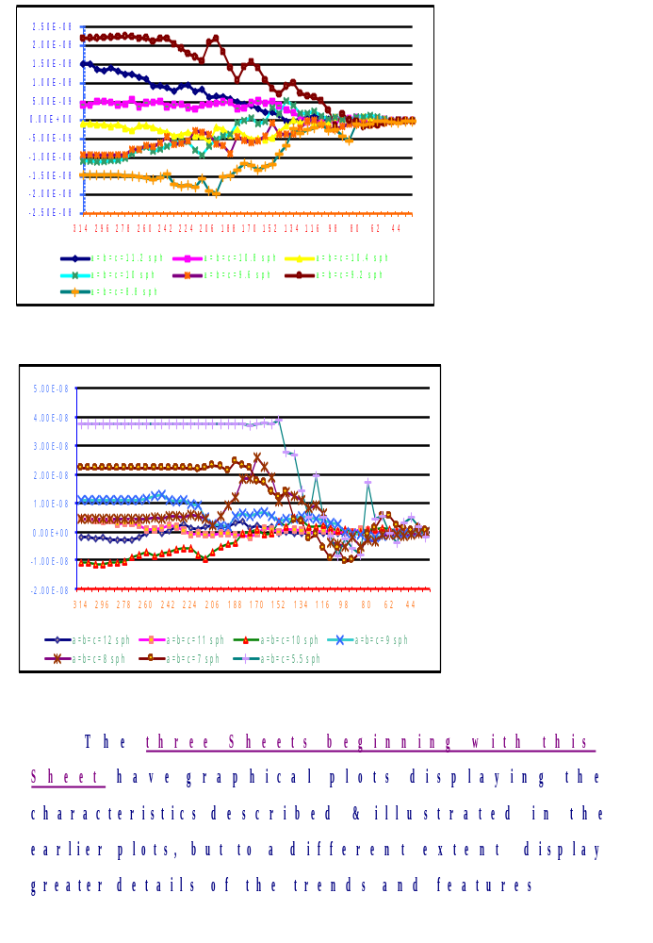
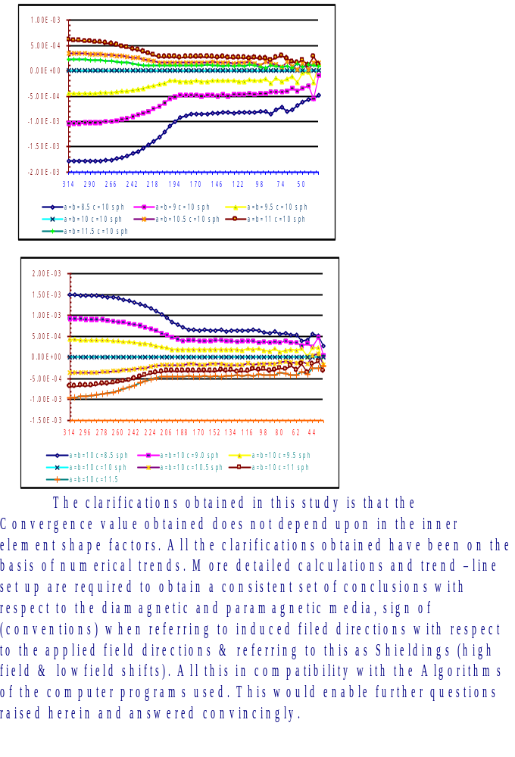
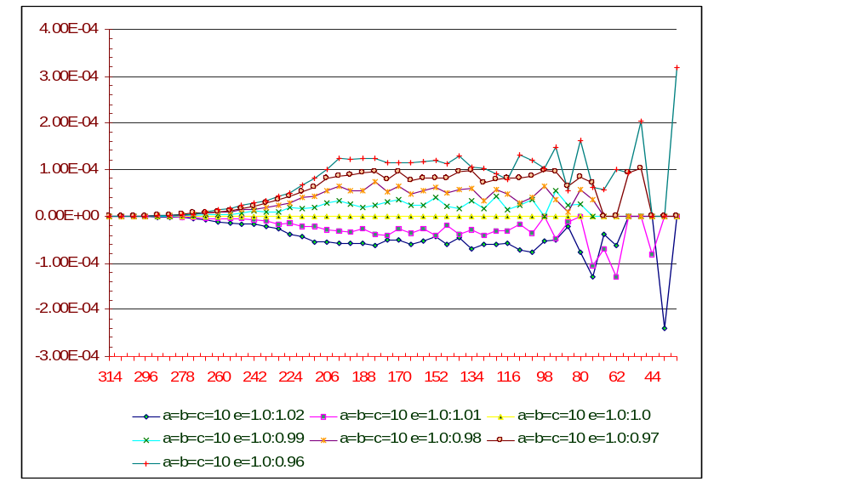

CONCLUSIONS:

For the two shapes {ellipsoidal and spherical} for the inner volume elements considered , it turns out that the convergence values (limiting summed up contributions) do not depend upon the shape factors of the inner volume elements.
Hence, the dependence of the summation (limiting) values on the Cubic/Non cubic lattice types can be considered exclusive of the inner volume element shape factors.
In the trends displayed in the following sheets taking ‘c’ axis as the applied magnetic field direction, for the significant changes when (1) a=b=fixed c=varied and (2) a=b=varied c=fixed, the corresponding trends in the changes of the limiting values for the summed up contributions of the Induced Fields “seem explainable” on the basis of the the number of dipoles which contribute from along the longitudinal and perpendicular directions.
As remarked earlier, explanations of this quantitative and qualitative trends seem worth considering further in detail since if the inner volume contribution reaches the same limiting value independent of the shape factor, then probably for any arbitrary shape of the element would the limiting value be the same as that of a sphere?
If for any arbitrary shape of the semimicro volume element the summed up contribution is the same, then can it be presumed for any arbitrary macroscopic specimen outer shape the same arbitrary shape can be considered for the inner volume element ( a hypothetical cavity) and at the central region(?) the induced field can be zero due to bulk susceptibility effects. This portends much simplification for the experimental studies HR PMR in solid state for the measurement of Shielding tensors in single crystal specimen.

Further verifications of the results presented here are being pursued for arriving at more reliable and categorical procedures for the SINGLE CRYSTAL HR PMR measurements of shielding tensors of protons

