UPDATE INFORMATION.

PHOTOGRAPHS – RE-OPENING FORT SCRATCHLEY NEWCASTLE
2008
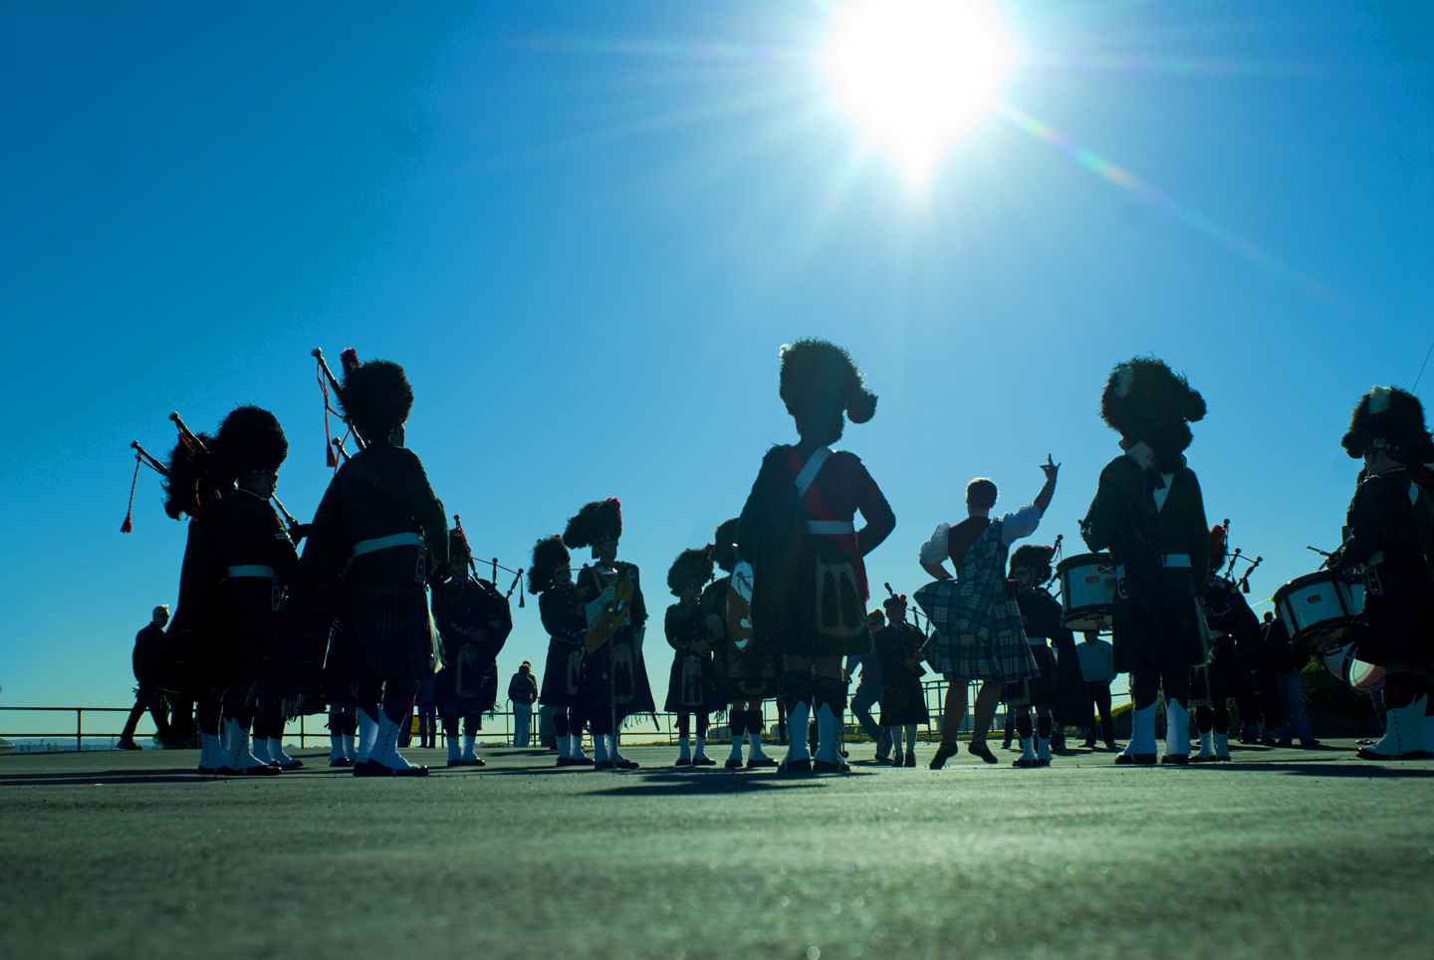

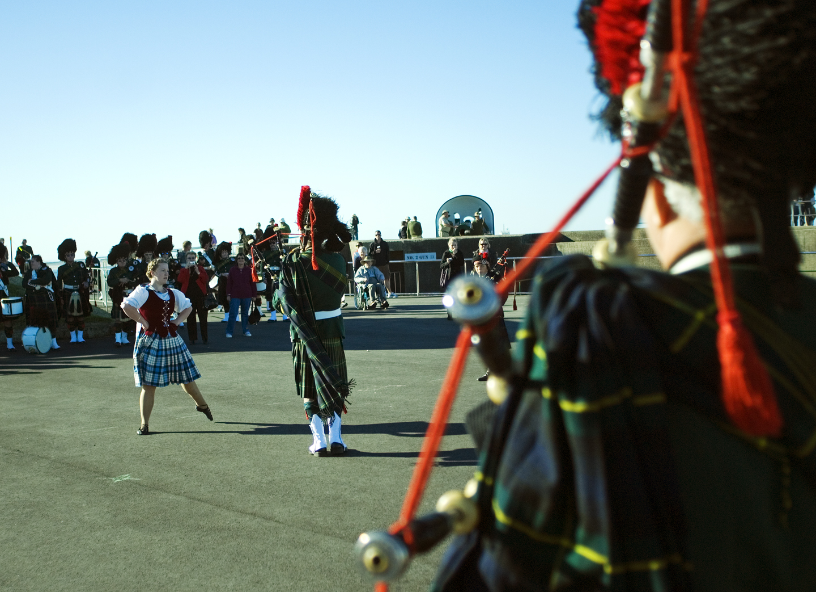

PHOTOGRAPHS COURTESY: STUART SCOTT

VALE: ALLEN CHRISTIE.

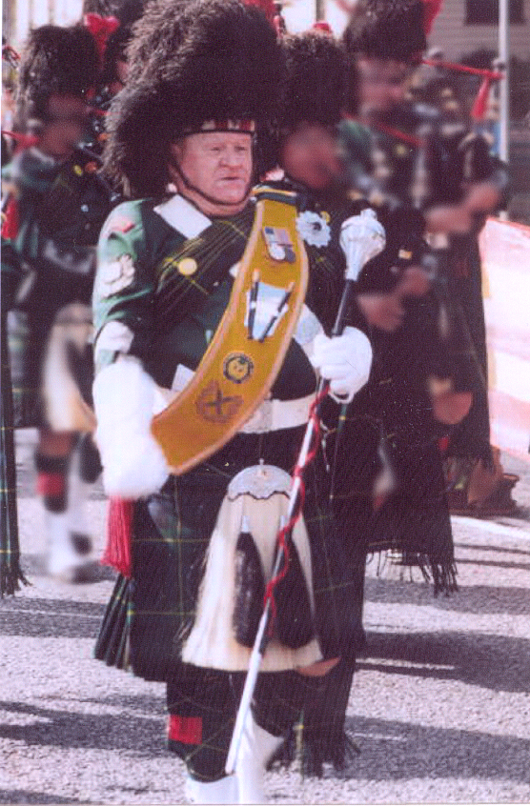

- Born: 11 January, 1940 at Wyong. Moved to Cooks Hill where he attended Cooks Hill Primary School then to Newcastle Junior High.
- Had a desire to join Bullen Brothers Circus.
- As an existing member of the Newcastle Police Citizens Boys Club Wickham, became a foundation member of that band and went on to become extremely proficient in the basic section of the Drum Corps.
- Offered a job as a stagehand to the famous hypnotist, Franquin and travelled widely in Australia and Hawaii.
- In 1960, Allen joined the CMF and served with the Field Artillery / Coastal Artillery and Anti-Aircraft Artillery.
- Became a Drum Major, becoming well known in this field Australia wide. Went on to become a top Adjudicator.
- Learned to play the Bagpipes.
- Moved on from the City Pipe Band to Charlestown; then to Adamstown RSL.
- Always interested in assisting ALL Pipe Bands in the region including the PCYC at Windale.
- Joined the RACT Pipes and Drums where he was able to combine his Pipe Band activities with that of his other Army commitments. He was with them until Army age retirement.
- “All Bands were My Bands” - said Allen.
- Accompanied United Mineworkers Pipe Band to France and UK.
- 1999, Allen returned to what he said was “his first band” -
The City of Newcastle RSL Pipe Band.
- Allen, after a very brave fight, passed away at Waratah, on 9 May 2005.
“Fondly Remembered - Always Loved”

“Gone from our sight, but never our memories;
Gone from our touch, but never our hearts”

- Copies of our DVD and CD are available from the Band.

DVD – “The Sights of Newcastle with the Sound of the City of Newcastle RSL Pipe Band Inc. ; $20

CD – “The Pipes and Drums of the City of Newcastle RSL Pipe Band Inc. / 80th Anniversary Year – 1924 – 2004” ; $15

~ ~ ~

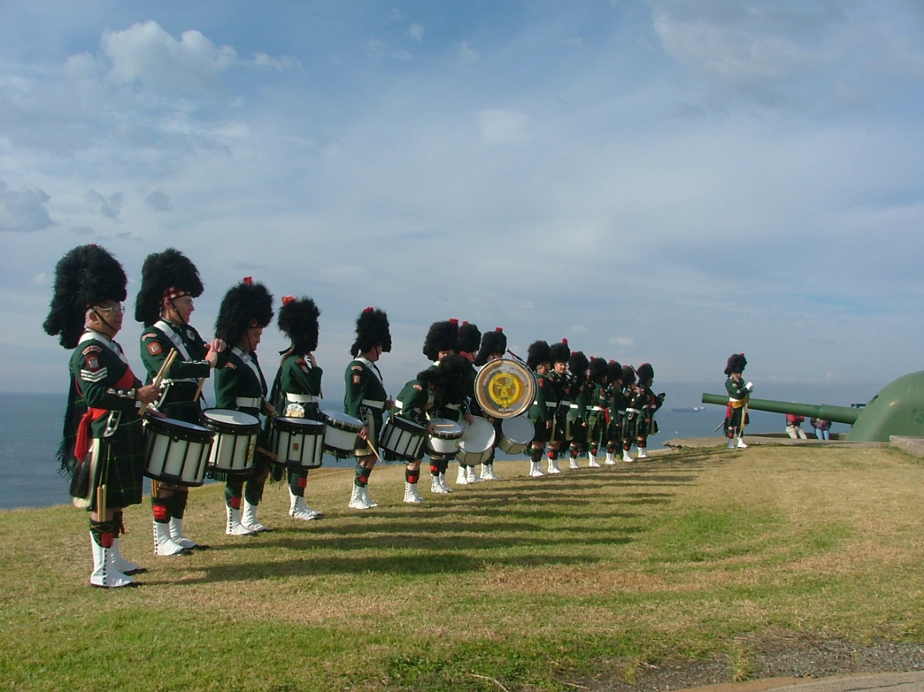

THE BAND AT FORT SCRATCHLEY – 2004

